**Advanced Approval in Salesforce CPQ:**

**Steps to install Advanced Approval Package:**

1. Go to <https://install.steelbrick.com/> and search for Advanced Approval
2. Select the latest version and click on Production   
   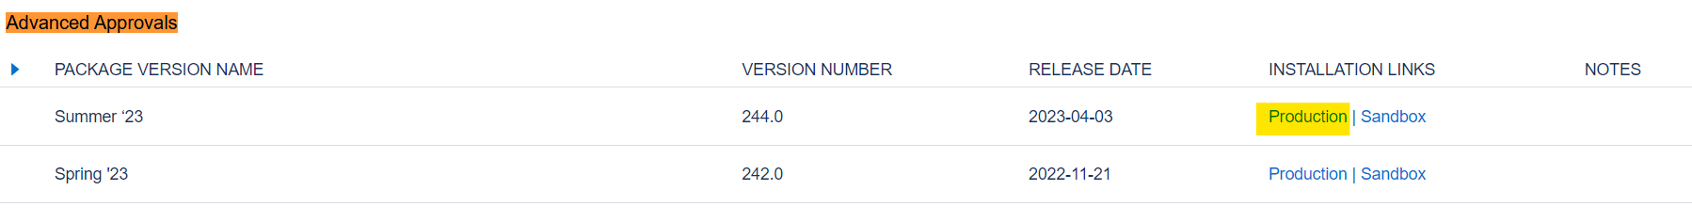
3. It will redirect to login page. Login to your org and select Install for Admin Users. Click on Install -   
   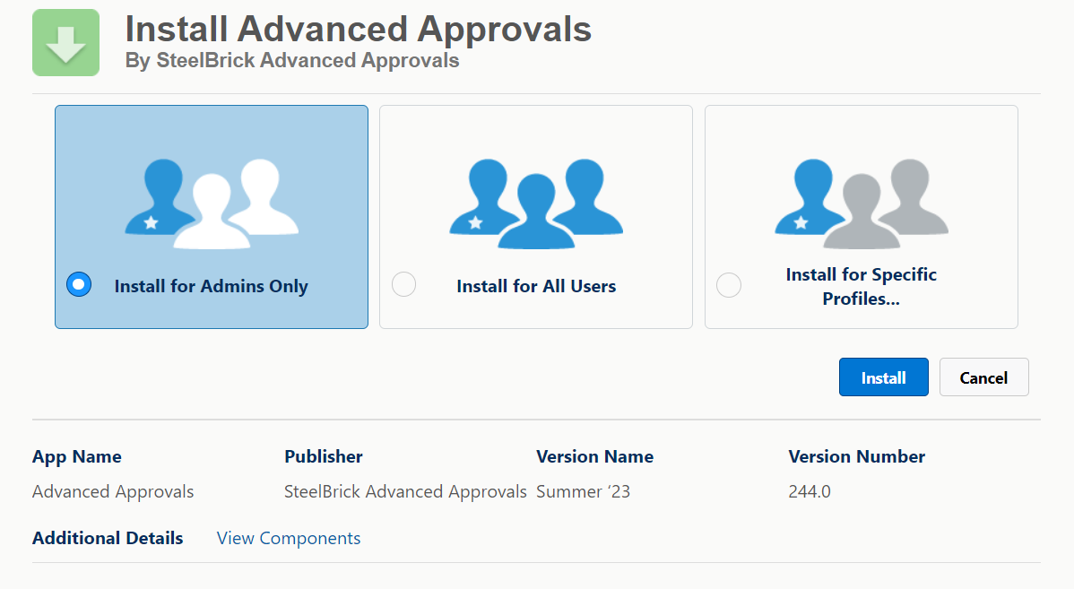

**Advanced Approval (AA)–**

Advanced Approvals use approval rules to determine which approvers receive approval requests and the email template used for sending the requests.

1. Sales reps submit records, like quotes or opportunities, for approval.
2. The Advanced Approvals package evaluates the approval rules associated with the record.
3. If any approval rule conditions are met, the rule runs, and approval request emails are sent to the designated approvers.
4. Approvers can be individual users or user groups with approval permissions within the organization.
5. Approval chains allow for sequential approval, and the record isn't approved until all approvers in all chains have confirmed their approval.
6. When an approval rule runs, an approval record is created for each approver who received an approval request.
7. The approval record contains information about the status of the approval request as it progresses through the approvers.
8. Both the submitted record and the corresponding approvals have approval status fields, enabling administrators and sales representatives to track their position in the approval process.

**Top of Form**

**Major Advance Approval Benefits**

* **Dynamic Approvers:** Simplify approval structure by programmatically swapping approvers.   
  *For example*: If we have an approval rule, if discount is greater than 40% and country is USA, then Approval should get assigned to APEC Sales VP, discount is 40% and country is Canada then it should get assigned to Canada Sales VP etc..
* **Approval Chains:** Allow for parallel, asynchronous approvals.
* **Smart Approvals**: Reduce time for approvals when submitting by remembering previous approvals.   
  *For example*: Approval process has 3 levels – Manager, VP, CRO. Lets say Manager and VP both approves the request but CRO declined the approval. The next time when approval request get trigged, by default Manager and VP don’t need to again approve it as they already approved that request. The pipeline will wait for CRO only to approve the request.

**Notes**: CPQ is must for Advance approvals. Opportunities may use AA out of the box, but any object may be enabled.

**Basic Approval Rule Configuration:**

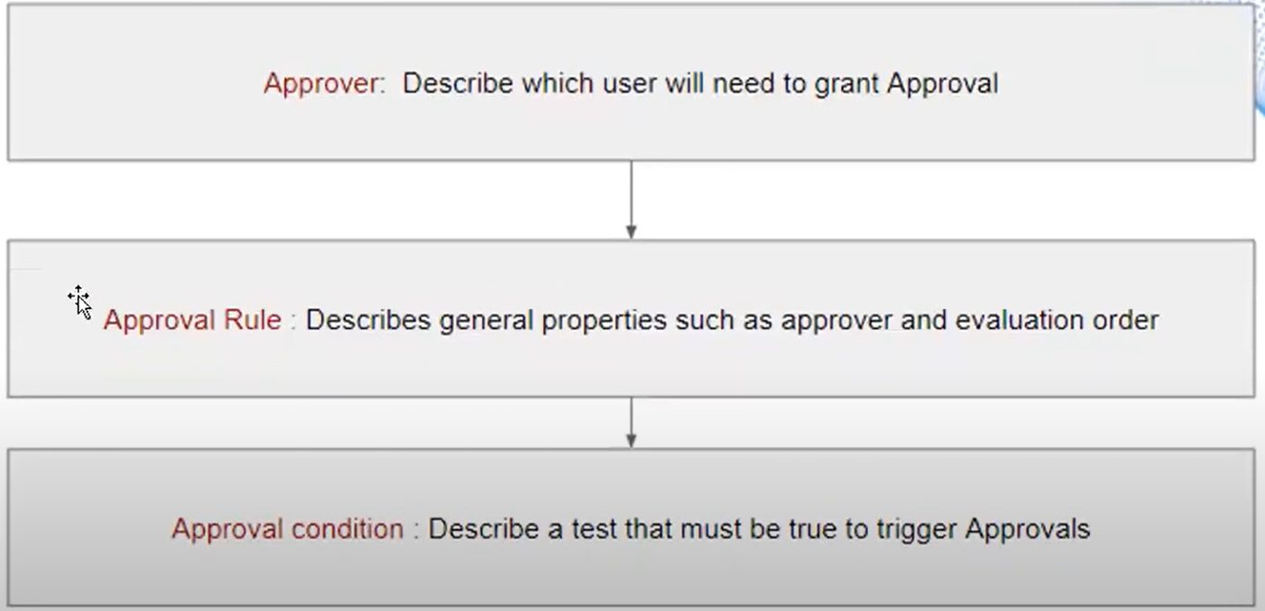

**Dynamic Approvers:**

**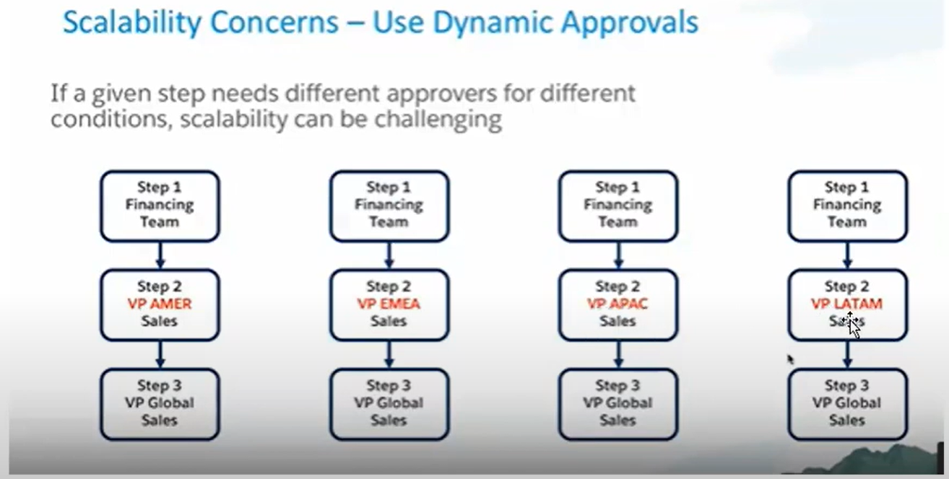  
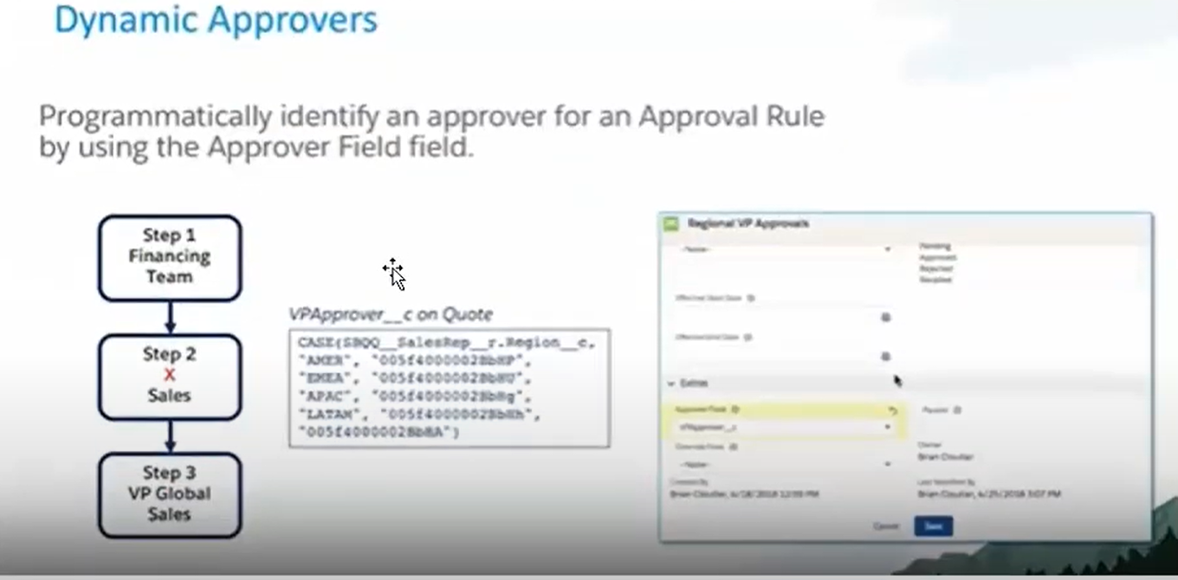**

**Approval Chain:**

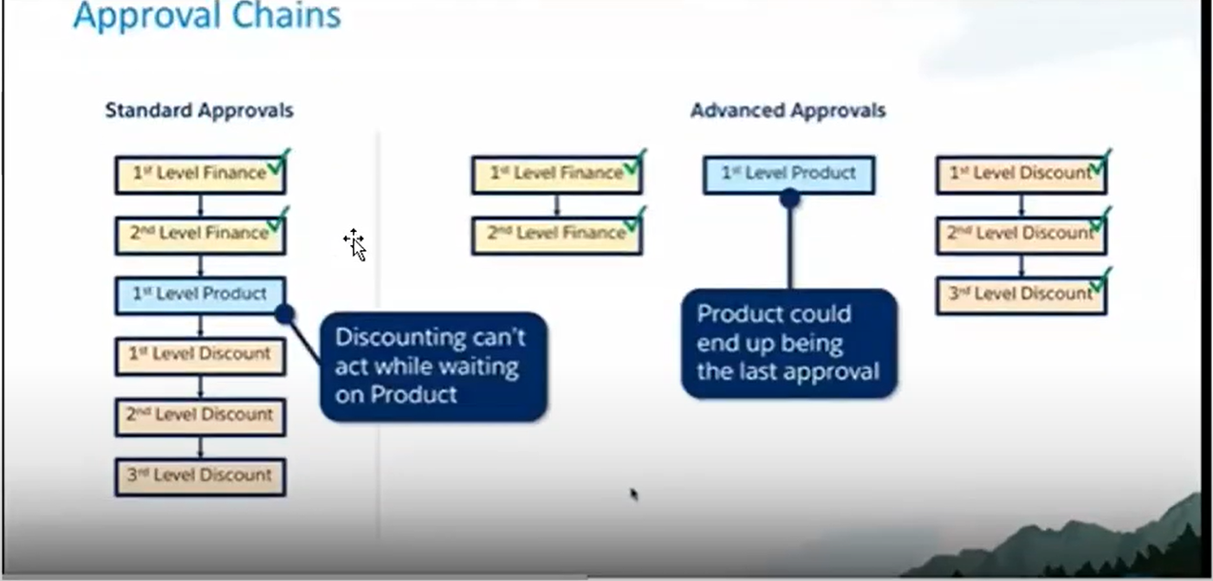

**Smart Approval:**

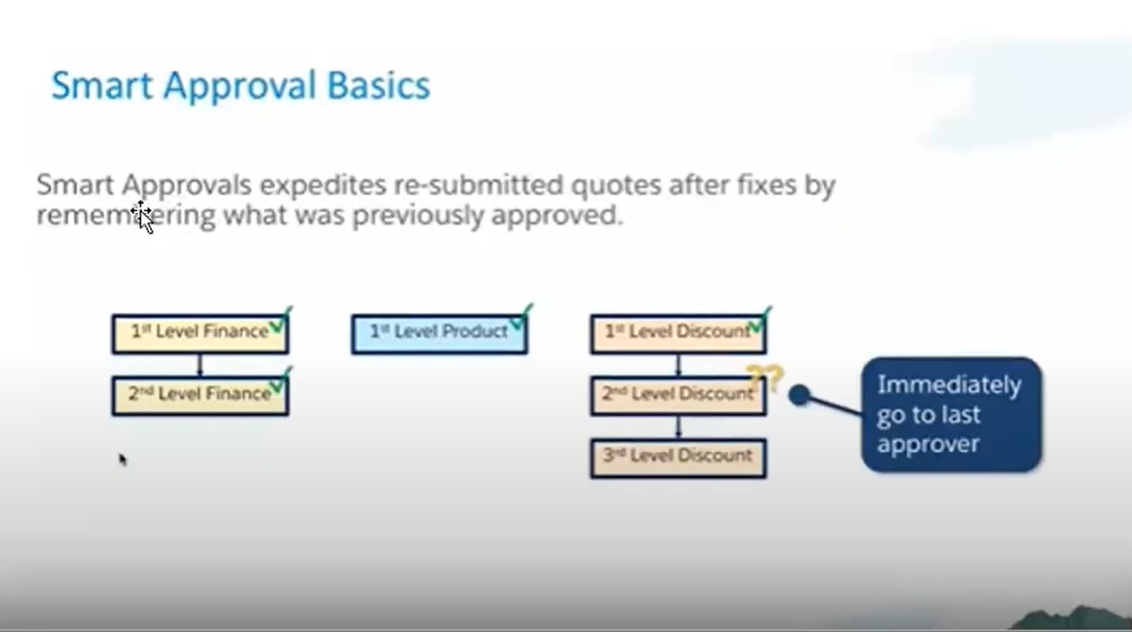

**Enable Approval for Quote Object:**

By default approval is only enabled for opportunity object. But we can use approval for any object. Under this section we are going to check how can we use approval with Quote. If you have any other object then please replace quote with that object.

**Steps-**

1. Go to Approval (sbaa__Approval__c ) object and create a new lookup field to quote object-
   1. Go to Object Manager and search for Approval. Go to field and relation ship
   2. Add a new field type will be lookup and select Quote object
   3. Provide access to required Profile. Don’t add this field to the Layout as it is a technical field.  
      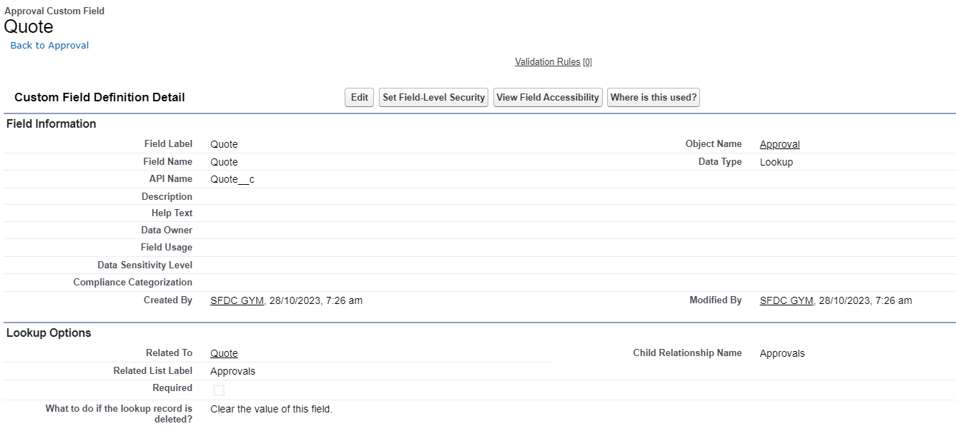
2. Create a picklist field on quote object
   1. Name: Approval Status (ApprovalStatus__c)
   2. Values- **Pending, Approved, Rejected, Recalled**
3. Create a date field on Quote object. This field stores the submitted date for the approval.
   1. **Name**: Submitted Date(SubmittedDate__c)
4. Create a user lookup field on the Quote object. This field stores the user record for the user who submitted the quote for approval.
   1. **Name**: Submitted User
   2. **API Name:** SubmittedUser_c
5. If you’re enabling advanced approvals on quotes, make sure the quote validation rule

**Invalid_First_Segment_term_end_Date** is inactive.

1. From Setup, in the Quick Find box, enter Apex Classes, and then select Apex Classes.
2. Create an Apex class titled **QuoteExtController** and add the following code. Remember, if you're enabling an object other than quotes, replace Quote with the object's name. Git link is <https://github.com/SFDCGYM/SalesforceCPQ/blob/main/QuoteExtController>

public with sharing class QuoteExtController {

private Id quoteId;

public QuoteExtController(ApexPages.StandardController stdController) {

quoteId = stdController.getId();

}

public PageReference onSubmit() {

if (quoteId != null) {

SBAA.ApprovalAPI.submit(quoteId, SBAA__Approval__c.Quote__c);

}

return new PageReference('/' + quoteId);

}

public PageReference onRecall() {

if (quoteId != null) {

SBAA.ApprovalAPI.recall(quoteId, SBAA__Approval__c.Quote__c);

}

return new PageReference('/' + quoteId);

}

}

1. Please also create the test cls for that. The git link for test class is given – <https://github.com/SFDCGYM/SalesforceCPQ/blob/main/QuoteExtControllerTests>
2. **Create Advanced approval button:**
   1. Create a Visualforce page. That page we will use on button-
      1. Setup> Visualforce page> New
      2. Label: SubmitQuote
      3. Name: SubmitQuote
      4. <apex:page standardcontroller='SBQQ__Quote__c' extensions='QuoteExtController' action='{!onSubmit}'>  
         <apex:pagemessages/>  
         </apex:page>  
         Git link is -   
         <https://github.com/SFDCGYM/SalesforceCPQ/blob/main/SubmitQuote>
   2. Create another VF page called RecallQuote –
      1. Label: RecallQuote
      2. Name: RecallQuote
      3. <apex:page standardcontroller='SBQQ__Quote__c' extensions='QuoteExtController' action='{!onRecall}'>  
         <apex:pagemessages/>  
         </apex:page>
   3. **Create buttons and link them to your Visualforce pages-**
      1. From Object Manager and then select Quote object.
      2. From the Buttons, Links, and Actions related list, click New Button or Link. *Create the following three buttons. Each button has a Display Type field of Detail Page Button and a height of 600.*
      3. **Button – Submit for Approval**
         1. **Buton Label**: Submit for Approval
         2. **Button Name**: Submit for Approval
         3. **Behaviour**: Display in existing window with sidebar
         4. **Content Source**: Visualforce Page
         5. **Visualforce Page**: Choose the SubmitQuote page   
            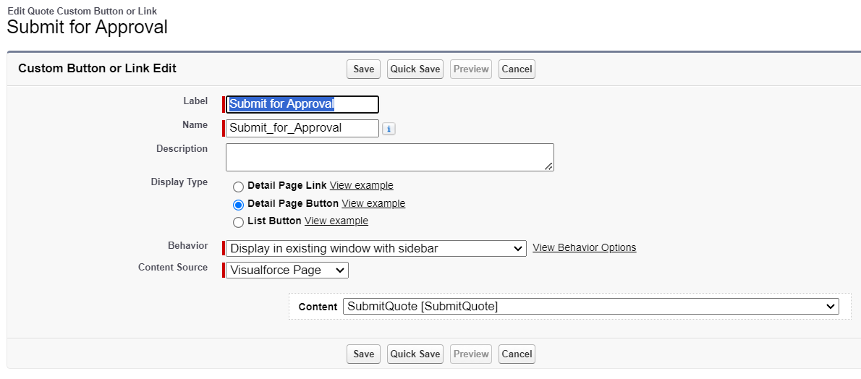
      4. **Button – Recall Approval**
         1. **Buton Label**: Recall Approval
         2. **Button Name**: Recall Approval
         3. **Behaviour**: Display in existing window with sidebar
         4. **Content Source**: Visualforce Page
         5. **Visualforce Page**: Choose the RecallQuote page
         6. 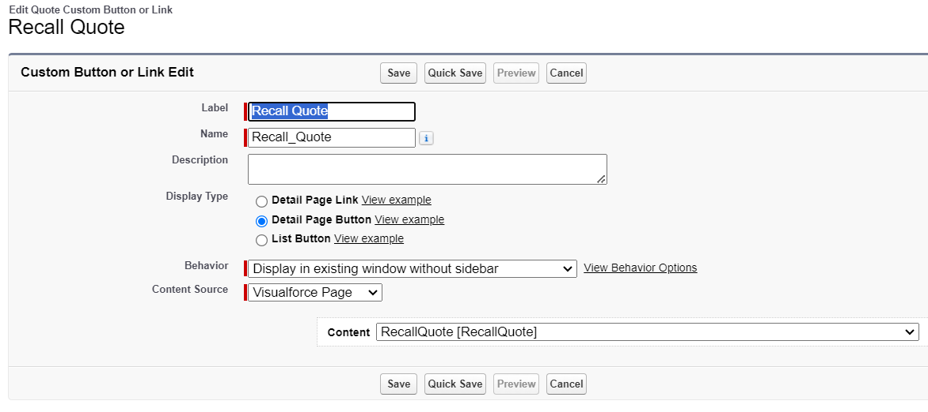
      5. **Button – Preview Approval**
         1. **Buton Label**: Preview Approval
         2. **Button Name**: Preview Approval
         3. **Behaviour**: Display in existing window with sidebar
         4. **Button or Link: URL-** /apex/sbaa__PreviewApprovals?Id={!SBQQ__Quote__c.Id}
         5. **Link Encoding**: Unicode (UTF-8)  
            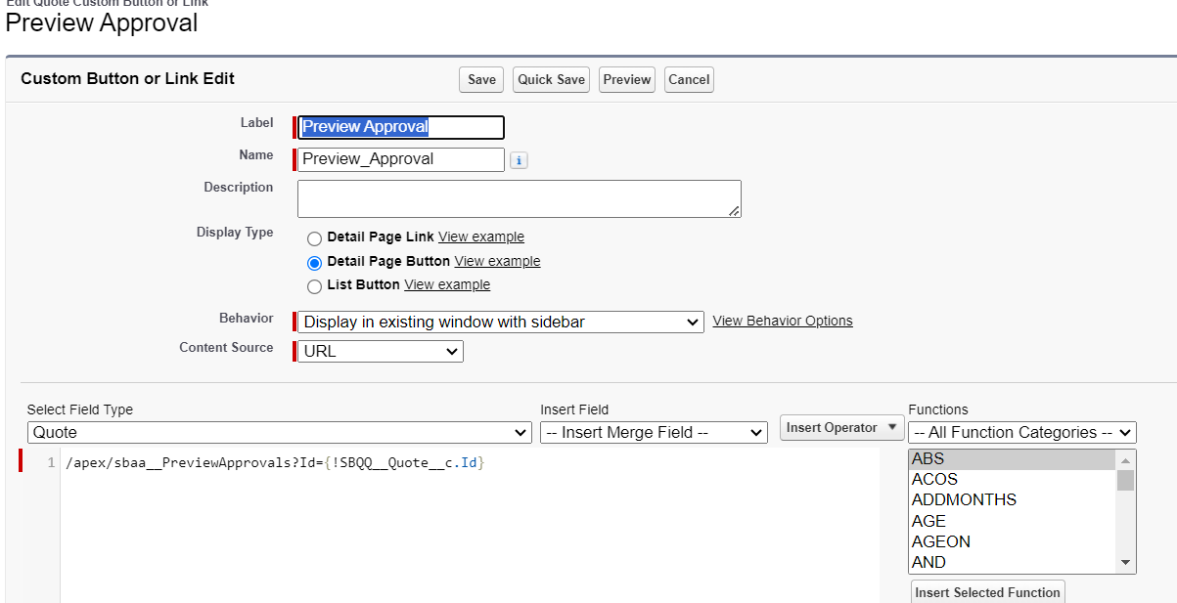
      6. Add all three buttons to the layout

**Interview Questions:**

1. Can you explain the role of approval chains and the sequence of approval steps in Advanced Approvals?
2. I don’t want to hardcode the approvals. Based on conditions I want to assign the approvals. How can I do that?
3. How do you configure multiple approval levels for a single approval process in Salesforce CPQ?
4. I want if the amount is more than 4000 USD, Quote should auto send to Approval. How can I do that?
5. What is the advantages over normal Approval and CPQ Approval Process?